# question

1. **Creating a Database named** lab3 **and table called** employee **with the following structure:**

| **Column Name** | **DataType** |
| --- | --- |
| eid | int |
| ename | varchar(20) |
| job | varchar(20) |
| country | varchar(25) |
| city | varchar(25) |
| salary | int |

1. **Inserting values into the `employee` table.**
2. **Select all information from the employee table.**
3. **Select employee name (ename) and job from the employee table.**
4. **Display all info from employee with County is `Germany` and Salary > 20,000.**
5. **Display ename, County, job, and Salary where job is `Programmers` or `Managers`.**
6. **Display all info where County is 'germany' and City is 'berlin' or 'Munich'.**
7. **All Information sorted in descending order.**

# Answer

Formatted Content from IMG_20250721_091609.jpg:

**sql**

CREATE DATABASE LAB3

CREATE TABLE EMPLOYEE(

E_ID INT,

E_NAME VARCHAR(20),

JOB VARCHAR(20),

COUNTRY VARCHAR(25),

CITY VARCHAR(25),

SALARY INT

);

INSERT INTO EMPLOYEE (E_ID, E_NAME, JOB, COUNTRY, SALARY)

VALUES(01,'PHURA','DESIGNER','GERMANY','30000'),

(02,'SURYA','ASSISTANT','INDIA','10000')

SELECT * FROM `employee`

SELECT E_NAME, JOB FROM employee

Formatted Content from IMG_20250721_091627.jpg:

sql

SELECT * FROM `employee` WHERE COUNTRY='GERMANY'

AND SALARY>=20000;

SELECT E_NAME,COUNTRY,JOB,SALARY FROM `employee` WHERE JOB='DOCTOR' OR JOB='ASSISTANT';

SELECT * FROM `employee` WHERE COUNTRY='NEPAL' OR CITY='NULL';

SELECT E_NAME FROM employee ORDER BY E_NAME ASC

SELECT E_NAME FROM employee ORDER BY E_NAME DESC

SELECT * FROM employee WHERE E_NAME LIKE "S%"

# Question with answer

**Lab Report 03**

**Title:** SQL Table and Data Queries

**Objective:**

To understand and implement SQL queries involving table creation, data insertion, and data retrieval using SELECT, WHERE, ORDER BY, and LIKE clauses.

**Description:**

In this lab session, a database named lab3 was created along with a table called employee. The table includes fields such as employee ID, name, job, country, city, and salary. Various SQL queries were executed to insert records and retrieve specific data based on different conditions, sorting, and filtering criteria.

**Questions and Answers:**

## Create a Database named lab3 and a table called employee with the following structure:

CREATE DATABASE lab3;

CREATE TABLE employee (

E_ID INT,

E_NAME VARCHAR(20),

JOB VARCHAR(20),

COUNTRY VARCHAR(25),

CITY VARCHAR(25),

SALARY INT

);

Output

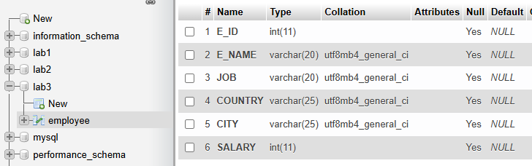

## Insert values into the employee table:

INSERT INTO employee (E_ID, E_NAME, JOB, COUNTRY, CITY, SALARY)

VALUES

(01, 'PHURA', 'DESIGNER', 'GERMANY', 'BERLIN', 30000),

(02, 'SURYA', 'ASSISTANT', 'NEPAL', 'POKHARA', 10000),

(03, 'SANTOSH', 'PROGRAMMER', 'CHINA', 'BEIJING', 20000),

(04, 'SALIM', 'MANAGER', 'NEPAL', 'KATHMANDU', 40000);

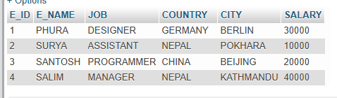

## Select all information from the employee table:

SELECT * FROM employee;



## Select employee name (E_NAME) and job from the employee table:

SELECT E_NAME, JOB FROM employee;

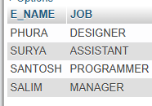

## Display all info from employee where COUNTRY is 'GERMANY' and SALARY > 20,000:

SELECT * FROM employee

WHERE COUNTRY = 'GERMANY' AND SALARY > 20000;



## Display E_NAME, COUNTRY, JOB, and SALARY where JOB is 'Programmers' or 'Managers':

SELECT E_NAME, COUNTRY, JOB, SALARY

FROM employee

WHERE JOB = 'PROGRAMMER' OR JOB = 'MANAGER';

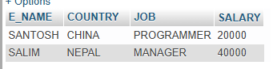

## Display all info where COUNTRY is 'GERMANY' and CITY is 'BERLIN' or 'MUNICH':

SELECT * FROM employee

WHERE COUNTRY = 'GERMANY' AND (CITY = 'BERLIN' OR CITY = 'MUNICH');

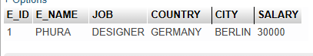

## Display all employee names in ascending and descending order:

1. **Ascending:**

SELECT E_NAME FROM employee ORDER BY E_NAME ASC;

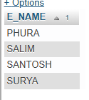

1. **Descending:**

SELECT E_NAME FROM employee ORDER BY E_NAME DESC;

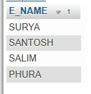

## Display all records where the employee name starts with 'S':

SELECT * FROM employee WHERE E_NAME LIKE 'S%';

**Output (Expected):**

| **E_ID** | **E_NAME** | **JOB** | **COUNTRY** | **CITY** | **SALARY** |
| --- | --- | --- | --- | --- | --- |
| 1 | PHURA | DESIGNER | GERMANY | BERLIN | 30000 |
| 2 | SURYA | ASSISTANT | INDIA | DELHI | 10000 |

Filtered outputs vary depending on the WHERE conditions in each query. For example:

* Query 5 will return only the employee "PHURA".
* Query 9 will return only "SURYA".

**Conclusion:**

This lab provided hands-on experience with fundamental SQL operations including database and table creation, data insertion, and retrieval using SELECT statements with conditions. These operations are critical for effective data manipulation and querying in relational databases.

Let me know if you’d like this report in a Word or PDF format too!